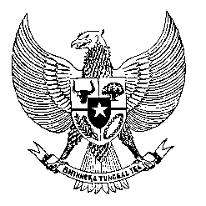

Permanent Mission
of the Republic of Indonesia to the UN, WTO,
and Other International Organizations
in Geneva

STATEMENT BY THE DELEGATION OF THE REPUBLIC OF INDONESIA
AT THE 38th SESSION OF THE UPR WORKING GROUP
CONSIDERATION OF THE UPR REPORT OF NAMIBIA
Geneva, 3 May 2021

Thank you, President,

Indonesia thanks the delegation of Namibia for the presentation of its national report.

Indonesia welcomes the achievements and good practices undertaken by Namibia since its last review, particularly in the fields of women empowerment and human rights education and training.

To further improve progress in the promotion and protection of human rights in Namibia, Indonesia recommends:

- to continue advancing human rights-based training programs for public service and law enforcement officials and the development of community policing initiatives, with a view to eradicate the practice of torture and other forms of ill-treatment;
- to further recognize the role of health and essential workers in defending human rights during the COVID-19 pandemic, and continue its work at the national and international levels in providing a safe and enabling environment for such workers; and
- to further strengthen the implementation of various sets of policies and laws dealing with gender-based violence and sexual violence, including by conducting training on gender mainstreaming in various related sectors.
We wish the Government of Namibia a successful review.

Thank you.

