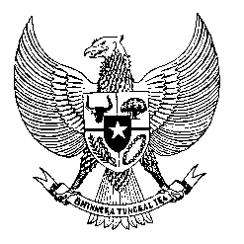

Permanent Mission
of the Republic of Indonesia to the UN, WTO,
and Other International Organizations
in Geneva

STATEMENT BY THE DELEGATION OF THE REPUBLIC OF INDONESIA
AT THE 38th SESSION OF THE UPR WORKING GROUP
CONSIDERATION OF THE UPR REPORT OF MOZAMBIQUE
Geneva, 4 May 2021

Thank you, President,

Indonesia thanks the delegation of Mozambique for the presentation of its national report.

Indonesia welcomes the steps taken by the government of Mozambique in implementing the recommendations from the previous review, particularly in strengthening the capacity of its national human rights institutions, as well as widening dialogue with civil society.

To further improve progress in the promotion and protection of human rights in Mozambique, Indonesia offers the following recommendations:

- Take further steps in curbing the rise of domestic violence cases during this COVID-19 pandemic including by prioritizing support for women and girls at the greatest risk of different types of violence.

- Accede to the International Covenant on Economic, Social and Cultural Rights and fully implement them into domestic law; and

- To further align the National Disability Policy with the UN Convention on the Rights of Persons with Disabilities.

We wish the Government of Mozambique a successful review.
Thank you.

