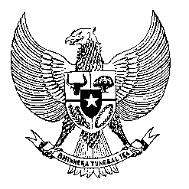

Permanent Mission
of the Republic of Indonesia to the UN, WTO,
and Other International Organizations
in Geneva

STATEMENT BY THE DELEGATION OF THE REPUBLIC OF INDONESIA
AT THE 38th SESSION OF THE UPR WORKING GROUP
CONSIDERATION OF THE UPR REPORT OF ESTONIA
Geneva, 4 May 2021
Thank you, President,

My Delegation welcome the Delegation of Estonia.

We appreciate the presentation of their national report and the progress made since the second review cycle, including the assignment of the Chancellor of Justice to act as the national human rights commission in compliance with the Paris Principles.

We also note the full use of digital technology in Estonian democracy, with tangible benefits during the pandemic.

We wish to recommend Estonia to:

- Ratify the Convention on Migrant workers

- Continue to take all necessary measures to combat child trafficking and sexual exploitation of children.

- Continue effort to eliminate discrimination against minorities in all sectors particularly employment and participation in decision-making position.

- Further recognize the role of health and essential workers in defending human rights during the COVID-19 pandemic, and continue its work at the national and international levels in providing a safe and enabling environment for such workers.
We wish Estonia every success in their review and subsequent implementation.
I thank you.

