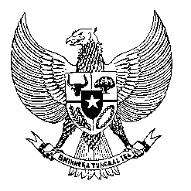

Permanent Mission
of the Republic of Indonesia to the UN, WTO,
and Other International Organizations
in Geneva

STATEMENT BY THE DELEGATION OF THE REPUBLIC OF INDONESIA AT
THE 38th SESSION OF THE UPR WORKING GROUP
CONSIDERATION OF THE UPR REPORT OF DENMARK
Geneva, 6 May 2021

Thank you, Madame President,
My Delegation appreciates the presentation of Denmark’s national report.
To further enhance the development made since the last review, we recommend the following:
- Uphold the rule of law and international human rights obligations in their effort to combat terrorism and terror-related crimes.

- Develop a comprehensive national human rights plan which incorporate actions to prevent xenophobia, racism and hate crimes, and further encourages social integration.

- To build a more inclusive society by improving national legislation and government programs aimed at ending discrimination based on ethnicities or religion.

- To ratify the Convention on Migrant Workers, and to ensure migrants and migrant children receive equal and fair treatments in the delivery of programs and social benefit.
My Delegation wishes Denmark every success in their review.
I thank you.

