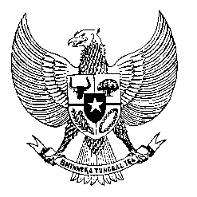

Permanent Mission
of the Republic of Indonesia to the UN, WTO,
and Other International Organizations
in Geneva

STATEMENT BY THE DELEGATION OF THE REPUBLIC OF INDONESIA AT
THE 38th SESSION OF THE UPR WORKING GROUP
CONSIDERATION OF THE UPR REPORT OF BELGIUM
Geneva, 5 May 2021

Thank you, Madame President,
Indonesia thanks Belgium for their national report. We take note some progress in human rights promotion and protection since their second review.
We wish to offer the following recommendations:
First, to provide a comprehensive mandate for its National Human Rights Commission in compliance with the Paris Principles
Second. to incorporate human rights-based training and applies sanction mechanism for law enforcement authorities who conduct racial profiling and use excessive violence in the performance of their duties.
Third, to take all necessary measures to prevent xenophobia, racism and hate crimes in the society, and investigate incidents including those happened against the Asian community in relation to Covid-19 pandemic.
Fourth, to place the best interest of the child as priority in migration policies including in family reunification.
We wish Belgium a successful review.
Thank you.

