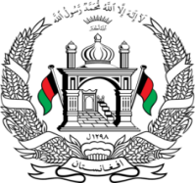
Permanent Mission of Islamic Republic of Afghanistan
Session of the UPR Working Group

Statement on the Review of Somalia

26 January 2021 at 9:00

Mr./Mme. (Vice) President,

Afghanistan warmly welcomes the distinguished delegation of Somalia to this meeting and thanks them for their engagement with the UPR.

Afghanistan welcomes the progress made on the legal framework for internally displaced persons and the development of a durable solutions initiative in support of its approach. We also welcome the ratification of the Convention on the Rights of Persons with Disabilities.

Mr./Mme. (Vice) President,

In the spirit of constructive engagement, my delegation wishes to make the following recommendations:

- Take steps to actively engage with internally displaced persons to gain a better understanding of their level of participation in public and political affairs.

- Take steps to invest in an enhanced, coherent, and comprehensive nationwide education system.

Finally, Afghanistan wishes Somalia every success in the review process.

I thank you, Mr./Mme. (Vice) President.

