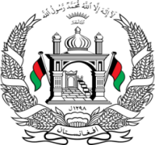
Permanent Mission of Islamic Republic of Afghanistan
Session of the UPR Working Group

Statement on the Review of Singapore

13May 2021

Mr./Mme. (Vice) President,

Afghanistan welcomes Singapore’s delegation and we commend it’s decision on the inclusion of all children with moderate to severe special education needs in the Compulsory Education Act.
In the spirit of constructive engagement, we wish to make the following recommendations:
1- Ensure respect for the right to seek asylum by enabling effective and unhindered access to the territory of Singapore, including the opportunity to apply for refugee status with UNHCR, and full compliance with the principle of non-refoulement.
2- Ratify the Optional Protocol to the Convention on the Rights of the Child on the sale of children, child prostitution and child pornography.
Finally, Afghanistan wishes Singapore every success in the review process.

I thank you, Mr./Mme. (Vice) President.

