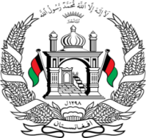
Permanent Mission of Islamic Republic of Afghanistan
Session of the UPR Working Group

Statement on the Review of Denmark

6 May 2021 - 9:00 AM

Mr./Mme. (Vice) President,

Afghanistan welcomes the distinguished delegation of Denmark to this meeting. We commend the positive developments since the previous cycle.

Afghanistan welcomes information provided on measures taken by the police to combat racism and various initiatives undertaken to facilitate access to the labor market by immigrants.

Mr./Mme. (Vice) President,

While we acknowledge the above achievements, we remain concerned that asylum- seeking families with children might be detained awaiting deportation, the best interests of the child are not adequately taken into account in immigration cases, and children aged 15 or older do not have an automatic right to family reunification.

In the spirit of constructive engagement, we wish to make the following recommendations:

- Take steps to extend the provision of education to refugee children, irrespective of residence status.
- Consider withdrawing the reservation made to article 40 (2) (b) of the Convention on the Rights of the Child.

Finally, Afghanistan wishes Denmark every success in the review process.

I thank you, Mr./Mme. (Vice) President.

