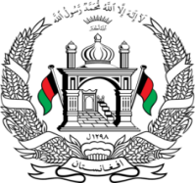
Permanent Mission of Islamic Republic of Afghanistan
Session of the UPR Working Group

Statement on the Review of Belgium

5 May 2021 at 14:30

Mr./Mme. (Vice) President,

Afghanistan cordially welcomes Belgian delegation. We commend the positive developments since the previous cycle,

Afghanistan welcomes measures taken to respond to arrivals of unaccompanied children and measures taken to combat all forms of discrimination.

Mr./Mme. (Vice) President,

We remain concerned about the number of unaccompanied and separated children subjected to different forms of abuse. We also concern about the incidence of disappearances among unaccompanied children transiting Belgium.

In the spirit of constructive engagement, we wish to make the following recommendations:

- Adopt measures to ensure that an individual assessment is carried out for each case of asylum, deportation, or expulsion, with full respect for principles of non-refoulement.

- Strengthen efforts to address the rise of intolerance and hate speech and ensure that the ban on wearing religious symbols in educational establishments does not negatively affect access to education for all.

Finally, Afghanistan wishes Belgium every success in the review process.

I thank you, Mr./Mme. (Vice) President.

