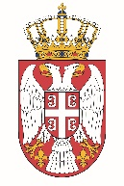

Permanent Mission of the Republic of Serbia to the United Nations Office in Geneva

Working Group for UPR
Interactive Dialogue on Report of Niger
May 2021

The Republic of Serbia welcomes the delegation of Niger and thanks the head of delegation for the comprehensive presentation of the UPR National Report.
Serbia commends all the efforts of the authorities of Niger in the previous period while implementing the recommendations from the previous cycle, and in particular welcomes the measures on establishing national mechanism for the prevention of torture.
In spirit of a constructive dialogue, we would like to recommend to Niger to make additional efforts in the systematic reduction of malnutrition among the population and to strengthen social policy through strategic measures in order to stabilize the food supply of the endangered part of the population.
We wish Niger a successful review process.

