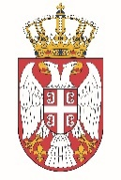

Permanent Mission of the Republic of Serbia to the United Nations Office in Geneva

Working Group for UPR
Interactive Dialogue on Report of Somalia
May 2021

The Republic of Serbia welcomes the participation of the delegation of Somalia at the 38 Session of the UPR.
We take this opportunity to commend all the measures Somalia has taken while implementing the recommendations from the previous cycle.
In particular we welcome its demonstrated political will to accelerate the submission of overdue treaty body reports, demonstrating its commitment to upholding its international human rights obligations.
We would like to recommend to Somalia the following:
- to invest additional efforts to improve the position of women, especially with regard to their participation in the public life of the country at the level of decision-making functions.

We wish Somalia a successful review process.

