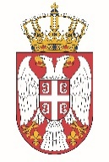

Permanent Mission of the Republic of Serbia to the United Nations Office in Geneva

Working Group for UPR
Interactive Dialogue on Report of Solomon Islands
May 2021

The Republic of Serbia warmly welcomes the participation of the delegation of Solomon Islands at the 38 Session of the UPR, and thanks for the presentation of the National Report.
We take this opportunity to commend all the measures Solomon Islands has taken while implementing the recommendations from the previous cycle.
In particular we welcome the efforts of the authorities of Solomon Islands on the adoption of anti-corruption laws and the establishment of an independent anti-corruption commission.
Serbia encourages the relevant authorities of Solomon Islands to continue close collaboration with the UN human rights bodies and mechanisms, as it is for the benefit of the situation of all its citizens.
We wish Solomon Islands a very successful review process.

