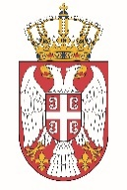

Permanent Mission of the Republic of Serbia to the United Nations Office in Geneva

Working Group for UPR
Interactive Dialogue on Report of Sierra Leone
May 2021

The Republic of Serbia welcomes the delegation of Sierra Leone and thanks the head of delegation for the presentation of the UPR National Report.
Sierra Leone has shown a respectful level of commitment to the UPR process in the previous period. Serbia in particular welcomes the measures aimed at strengthening the independence of judiciary, as well as the efficient manner Sierra Leone has responded to the COVID-19 pandemic.
In spirit of a constructive dialogue, we would like to recommend to Sierra Leone to strive to allocate sufficient funds for the health sector in order to equip health care institutions ensuring so the provision of quality basic care and services for newborns.
Serbia wishes Sierra Leone a fruitful review process.

