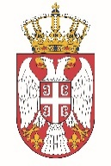

Permanent Mission of the Republic of Serbia to the United Nations Office in Geneva

Working Group for UPR
Interactive Dialogue on Report of Paraguay
May 2021

The Republic of Serbia welcomes the delegation of Paraguay and thanks the head of delegation for the comprehensive presentation of the UPR National Report.
Serbia takes this opportunity to commend all the efforts of the authorities of Paraguay in the previous period while implementing the recommendations from the previous cycle, and in particular welcomes the measures on increasing the number of State agencies for human rights strengthening so the institutional framework
In spirit of a constructive dialogue, we would like to recommend to Paraguay to invest additional efforts to improve the position of women and children in rural areas of the country, especially in terms of employment and participation in public life (for women) and in the field of education (for children).
We wish Paraguay a successful review process.

