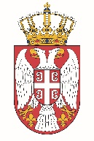

Permanent Mission of the Republic of Serbia to the United Nations Office in Geneva

Working Group for UPR
Interactive Dialogue on Report of Mozambique
May 2021

The Republic of Serbia welcomes the delegation of Mozambique and thanks the head of delegation for the presentation of the UPR National Report.
Mozambique has shown a respectful level of commitment to the UPR process in the previous period. Serbia in particular welcomes the increase of women’s political participation in decision-making bodies, providing better gender parity.
In spirit of a constructive dialogue, we would like to recommend to Mozambique to take measures to improve quality and access to primary health care services in rural areas and to ensure the availability of qualified health personnel.
Serbia wishes Mozambique a fruitful review process.

