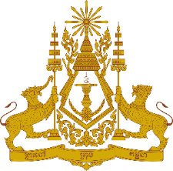
PERMANENT MISSION OF THE KINGDOM OF CAMBODIA
TO THE UNITED NATIONS AT GENEVA

Statement by Cambodia
At the 38th Session of the UPR Working Group
UPR of Singapore
12 May 2021, Geneva
[Speaking Time: 45 seconds]

Madam President!

- Cambodia recognizes Singapore’s remarkable achievements made in the implementation of recommendations from the previous cycle, and congratulates Singapore’s significant progress in the areas of housing, health care, education, protection of the elderly, and prevention of human trafficking.

- My delegation commends Singapore’s responses to the Covid-19 pandemic, including the inoculation rollout and the creation of the Emerging Stronger Taskforce to identify opportunities in the post-COVID world. We also welcome Singapore’s adoption of various legislations and policies in support of vulnerable groups of children, women and persons with disabilities.

- In the constructive spirit, Cambodia would like to offer two recommendations for Singapore’s consideration:
- Continue provision of social support to vulnerable groups, especially those disproportionately affected by the Covid-19 pandemic
- Take additional steps to further enhance the right to education among less privileged children

- I wish the delegation of Singapore every success in this exercise.

*****

