Mission Permanente  du Royaume du Maroc  Genève | 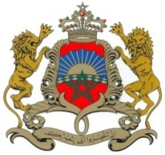

38ème Session de l’Examen Périodique Universel
Déclaration du Royaume du Maroc
Examen des Iles Solomon
Genève, le 10 mai 2021

Madam President,

The Kingdom of Morocco welcomes Solomon Islands’ participation in the UPR and notes the positive steps taken since its last review.
Morocco would like to recommend to the Government of Solomon Islands to consider the ratification of : 1. the Optional Protocols to the Convention on the Rights of the Child, and 2. develop and adopt a policy on child labour and a hazardous labour list; as well as take the necessary measures to ensure that no child under 18 is engaged in hazardous labour, including in the agriculture, logging, tourism and fishing industries
My delegation recommends, as well, the ratification of 3. CAT and 4. The Convention on Rights of Migrants and member of their families.
We wish Solomon Islands all the success in its review.

Thank you Madam President.

