Mission Permanente  du Royaume du Maroc  Genève | 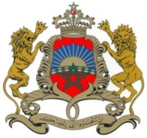
38ème Session de l’Examen Périodique Universel
Déclaration du Royaume du Maroc
Examen de Singapour
Genève, le 12 mai 2021

Madam President,

The Kingdom of Morocco welcomes Singapore’s participation in the UPR and notes the positive steps taken since its last review.
Morocco takes note with satisfaction of the full commitment by the Singaporean Government to its obligations under the Convention on the Rights of the Child, as well as the submission of the combined 4th and 5th reports to the CRC in 2019.
My delegation welcomes the continuous development by the Government of Singapore of the five-year plans, known as Enabling Masterplans, comprising measures to integrate persons with disabilities into society.
Finally, Morocco would like to recommend to the Government of Singapore to consider the ratification of (i) the Convention against Torture and Other Cruel, Inhuman or Degrading Treatment or Punishment, (ii) the International Convention on the Protection of the Rights of All Migrant Workers and Members of Their Families and (iii) the International Convention for the Protection of All Persons from Enforced Disappearance.

Thank you Madam President.

