Mission Permanente  du Royaume du Maroc  Genève | 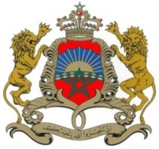

38ème Session de l’Examen Périodique Universel
Déclaration du Royaume du Maroc
Examen du Paraguay
Genève, le 05 mai 2021

Madam President,

The Kingdom of Morocco welcomes Paraguay’s participation in the UPR and notes the positive steps taken since its last review.
Morocco takes note of the the Adoption of the Paris Agreement on climate change by the Government of Paraguay, as well as the Act No. 6676/20, under which the transformation and conversion of areas in the eastern region with forest cover are prohibited (“zero deforestation” for 10 years).
Finally, Morocco would like to recommend to the Government of Paraguay to consider the ratification of the Optional Protocol to the International Covenant on Economic, Social and Cultural Rights.

Thank you Madam President.

