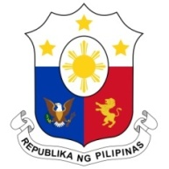
PHILIPPINES

Human Rights Council
38th Session of the Working Group on the Universal Periodic Review
3 May 2021, Palais des Nations, Geneva, Switzerland

THE NIGER

Speaking Time: 1 min 05 seconds
Speaking Order: 75 of 101

Thank you, Chair.

The Philippines warmly welcomes the delegation of the Niger.

We are pleased to note Niger's steady efforts to bring its domestic legislation into line with international and regional instruments.

We also commend the country's continued efforts to strengthen its National Human Rights Commission which regained its A status in 2017.

In a constructive spirit, the Philippines presents the following recommendations:

- Ensure the allocation of adequate resources for measures to combat slavery and trafficking in persons and for programs to rehabilitate victims;

- Take steps to strengthen data collection on gender-based violence against women and girls to ensure informed and responsive policy interventions; and

- Further strengthen regional and international partnerships to harness technical and financial assistance for development and human rights.

We wish the Niger every success in this review cycle.
Thank you, Chair. END.

