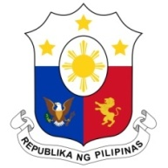
PHILIPPINES

Human Rights Council
38th Session of the Working Group on the Universal Periodic Review
10 May 2021, Palais des Nations, Geneva, Switzerland

SOLOMON ISLANDS

Speaking Time: 1 min 45
Speaking Order: 29 of 66

Thank you, Chair.

The Philippines welcomes the delegation of the Solomon Islands.

We recognize Solomon Islands’ constructive approach to the UPR process.

We are pleased to note the government´s efforts to further advance the protection of human rights especially of vulnerable groups. We welcome in this regard the establishment of the Anti-Human Trafficking Advisory Committee, the training of law enforcement officials, and the strengthening of legislation to combat trafficking in persons.

In a constructive spirit, the Philippines presents the following recommendations:

- Ensure that policies relating to the environment take into consideration their impact on human rights and on communities;

- Step up efforts to protect children from commercial sexual exploitation including prostitution and child pornography; and

- Take further steps to increase the participation of women in public service and enhance measures for women´s economic empowerment.

We wish the Solomon Islands every success in this review cycle.

Thank you, Chair. END.

