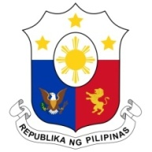
PHILIPPINES

Human Rights Council
38th Session of the Working Group on the Universal Periodic Review
10 May 2021, Palais des Nations, Geneva, Switzerland

SEYCHELLES

Speaking Time: 1 min 20
Speaking Order: 36 of 87

Thank you, Chair.

The Philippines warmly welcomes the delegation of Seychelles.

We are pleased to note Seychelles’ enactment of the National Council for the Elderly Act 2018 and the Domestic Violence Act 2020. We also welcome the legislative and policy reforms and interventions to better protect children, including from sexual abuse and exploitation.

We thank Seychelles’ engagement with the origin countries of its migrant worker populations with a view to preventing and addressing trafficking in persons.

In a constructive spirit, the Philippines presents the following recommendations:

- Continue to strengthen measures to address and prevent gender-based violence and discrimination;

- Increase access to justice for women and girls and protection services for victims of domestic violence; and

- Ensure access to education and health services for persons with disabilities, and the allocation of adequate resources for said services.

We wish the Seychelles every success in this review cycle.

Thank you, Chair. END.

