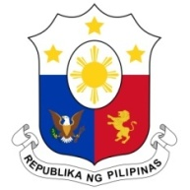
PHILIPPINES

Human Rights Council
38th Session of the Working Group on the Universal Periodic Review
12 May 2021, Palais des Nations, Geneva, Switzerland

SINGAPORE

Speaking Time: 0 min 45
Speaking Order: 104 of 141

Thank you, Chair.

The Philippines thanks Singapore for its constructive engagement in the UPR process.

We commend Singapore on its ratification of the ICERD in 2017 and welcome the government’s intensified efforts to protect children and youth from sexual exploitation and other forms of abuses and neglect.

In a constructive spirit, the Philippines presents the following recommendations:

- Continue efforts to uphold and protect the rights, safety, health, and welfare of migrant workers including during the Covid-19 pandemic;

- Further strengthen programs and services that are available to migrant workers, including those related to mental health; and

- Continue to ensure the provision of adequate protection and support for victims of trafficking in persons, especially women and children.

We wish our ASEAN partner every success in this review cycle.

Thank you, Chair. END.

