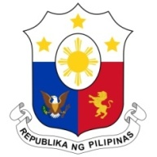
PHILIPPINES

Human Rights Council
38th Session of the Working Group on the Universal Periodic Review
5 May 2021, Palais des Nations, Geneva, Switzerland

PARAGUAY

Speaking Time: 1 min 25
Speaking Order: 56 of 83

Thank you, Chair.

The Philippines warmly welcomes the delegation of Paraguay.

We commend Paraguay on its development and implementation of the SIMORE system for monitoring human rights recommendations and their implementation.

The Philippines is also pleased to note the efforts made by the government in strengthening measures to protect the rights of vulnerable groups including women, children, indigenous peoples, among others.

In a constructive spirit, the Philippines presents the following recommendations:

- Further strengthen inter-institutional as well as multi-sectoral cooperation in the development and implementation of programs to combating trafficking in persons, especially women and children;

- Strengthening statistical data collection to help inform appropriate interventions for preventing and combating all forms of violence against women and girls; and

- Ensure adequate measures for promoting the meaningful participation of indigenous peoples in all public decision-making processes affecting them.

We wish Paraguay every success in this review cycle.

Thank you, Chair. END.

