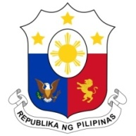
PHILIPPINES

Human Rights Council
38th Session of the Working Group on the Universal Periodic Review
3 May 2021, Palais des Nations, Geneva, Switzerland

NAMIBIA

Speaking Time: 1 minute
Speaking Order : 107 of 113

Thank you, Chair.

The Philippines warmly welcomes the delegation of Namibia.

We are pleased to note the efforts of Namibia to further improve the participation of young women and girls in education.

We are also encouraged by the continued efforts to mainstream human rights education and welcome the passage of a number of laws aimed at enhancing human rights protection.

In a constructive spirit, the Philippines presents the following recommendations:

- Ensure that the needs of children with disabilities are adequately addressed in policy measures on inclusive education;

- Continue to conduct public awareness-raising and capacity-building programs on trafficking in persons for duty bearers;

- Enhance measures to address gender-based violence and ensure appropriate and adequate remedies and protection for the victims; and

- Consider ratifying the ICRMW.

We wish Namibia every success in this review cycle.

Thank you, Chair END.

