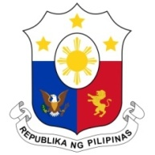
PHILIPPINES

Human Rights Council
38th Session of the Working Group on the Universal Periodic Review
4 May 2021, Palais des Nations, Geneva, Switzerland

MOZAMBIQUE

Speaking Time: 1 minute
Speaking Order: 89 of 110

Thank you, Chair.

The Philippines warmly welcomes the delegation of Mozambique.

We welcome the efforts made by Mozambique in strengthening women's political participation and in combating gender inequalities.

As a supporter and donor of technical cooperation programs of the OHCHR, the Philippines acknowledges the technical cooperation between Mozambique and the UN on human rights and encourages further constructive work in this regard.

In a constructive spirit, the Philippines presents the following recommendations:

- Address issues that limit the participation of young women and girls in the education system;

- Ensure the participation of women and local communities in the design and implementation of policies and programs to combat gender-based violence and discrimination; and

- Ensure the allocation of adequate resources for programs on children's rights.

We wish Mozambique every success in this review cycle.
Thank you, Chair. END.

