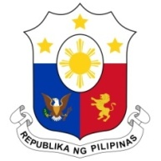
PHILIPPINES

Human Rights Council
38th Session of the Working Group on the Universal Periodic Review
6 May 2021, Palais des Nations, Geneva, Switzerland

DENMARK

Speaking Time: 1 min
Speaking Order: 26 of 117

Thank you, Chair.

The Philippines welcomes the delegation of Denmark.

We are pleased to note the efforts made to strengthen response against trafficking in persons and provide comprehensive assistance to victims.

In a constructive spirit, the Philippines presents the following recommendations:

- Ensure that child victims of trafficking are not treated as offenders and are provided child and gender-sensitive legal and psychosocial assistance and support.

- Take steps to strengthen community-based care for children with disabilities;

- Take concrete measures to address stigma, discrimination and exclusion faced by persons living with Down syndrome and ensure provision of adequate support for them and their families and carers;

- Ensure that concerns and situation of migrant women are adequately reflected in strategies to address gender-based violence and harassment; and

- Consider ratifying the ICRMW.

We wish Denmark every success in this review cycle.

Thank you, Chair. END.

