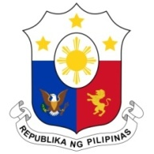
PHILIPPINES

Human Rights Council
38th Session of the Working Group on the Universal Periodic Review
5 May 2021, Palais des Nations, Geneva, Switzerland

BELGIUM

Speaking Time: 55 seconds
Speaking Order: 121 of 123

Thank you, Chair.

The Philippines welcomes the delegation of Belgium.

The Philippines acknowledges Belgium's efforts to address gender pay gap and domestic violence.

In a constructive spirit, the Philippines presents the following recommendations:

- Intensify capacity building programs on race and gender-based violence for duty bearers to ensure systematic reporting of and response on all cases;

- Take steps to ensure the meaningful participation of persons with disabilities in political and public decision-making processes;

- Ensure equitable access to health services, including Covid-19 vaccines, for all vulnerable groups including migrant workers regardless of migration status;

- Ensure provision of adequate protection, remuneration and support services for domestic workers;

- Stop the detention of children due to immigration-related reasons; and

- Ratify the ICRMW.

We wish Belgium every success in this review cycle.

Thank you, Chair. END.

