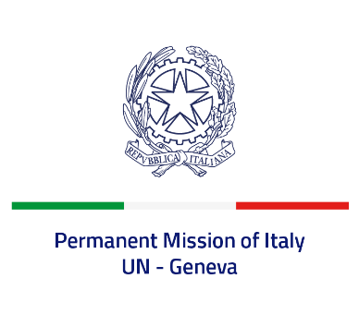
Check against delivery
UPR 38 – Seychelles
Monday 10 May 2021, 14:30 – 18:00

Delivered by: Minister Marie Sol Fulci, Deputy Permanent Representative of Italy

(Focal point: Daniele Borrelli, Counsellor)
Thank you, Madam President.

We thank the distinguished delegation of Seychelles for their national report and presentation.

Italy welcomes the establishment in 2019 of the Truth, Reconciliation, and National Unity Commission (TRNUC). We also welcome the commitment to strengthen the prevention of gender-based violence, including through the Domestic Violence Bill adopted in 2020, the decriminalisation of same sex relationships and the prohibition of all corporal punishment of children.
Italy seizes this opportunity to offer Seychelles the following recommendations:

- Adopt measures to address trafficking in persons, including child, especially trafficking for purposes of sexual exploitation.
- Continue the efforts to prevent gender-based violence and to assist the victims.
- Consider acceding to the Optional Protocol of the Convention against Torture and to the Optional protocol to the International Covenant on Economic, Social and Cultural Rights.
- Ratify the Optional Protocol to the Convention on the Rights of the Child on a communications procedure and the Optional protocol to the Convention on the Rights of Persons with Disabilities

We wish Seychelles a successful review.
I thank you.

