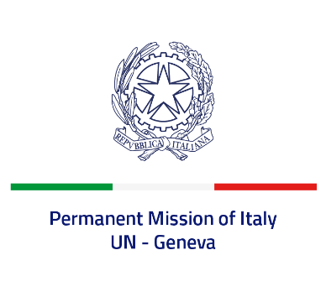
Check against delivery
UPR 38 – Latvia
Tuesday 11 May 2021, 09:00 – 12:30

Delivered by: Minister Marie Sol Fulci, Deputy Permanent Representative of Italy

(Focal point: Daniele Borrelli, Counsellor)

Thank you, Madam President.

We thank the distinguished delegation of Latvia for their national report and presentation.

Italy welcomes the measures aimed at promoting gender equality and eliminating gender-based violence, including the adoption of the first National Action Plan on the Implementation of the UN Security Council Resolution 1325 on Women, Peace and Security in Latvia for 2020-2025.
Italy also welcomes the adoption of the Law on the discontinuation of the Non-citizen’s Status for children, automatically granting Latvian citizenship to all children born after 1st January 2020 irrespective of their parents’ status.
Italy seizes this opportunity to offer Latvia the following recommendations:

- Continue fighting gender-based violence and prioritise the swift ratification of the Council of Europe Convention on preventing and combating violence against women and domestic violence.
- Ratify the International Convention for the Protection of All Persons from Enforced Disappearance.
- Continue efforts to reduce statelessness and facilitate the acquisition of nationality by non-citizens.

We wish Latvia a successful review.
I thank you.

