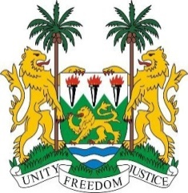
PERMANENT MISSION OF SIERRA LEONE TO
THE UNITED NATIONS IN GENEVA

38th Session of the Universal Periodic Review
(3 – 14 May 2021)
Niger

Monday 3 May 2021 – 2:30 – 6:00

Madam President,
Sierra Leone welcomes the delegation of Niger to the UPR Working Group.
We would like to commend Niger first of all for the wide-ranging efforts it is taking to respond to terrorist attacks, particularly in the western regions of Tillabéri and Tahoua.
My delegation welcomes the development of a national framework to promote human rights, including the National Human Rights Commission and the national mechanism for the prevention of torture.
We further commend Niger for enacting Decree No. 935-2017, which offers protection, support and assistance for girls attending school, and for the establishment of its national gender policy.
Sierra Leone would like to make the following recommendations to be part of the ongoing reform efforts:
- Repeal all discriminatory legislation against women and girls, including those related to early and forced marriage, and lift all reservations on CEDAW, as already agreed during the previous UPR cycle
- Strengthen the capabilities of the National Human Rights Commission by allocating the necessary financial, human and material resources.
Our delegation wishes Niger a successful UPR outcome.
I thank you, Madam President

