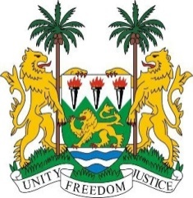

**SIERRA LEONE**

**38th Session of the UPR** (3-14 May 2021)

**UPR Review of Somalia**

06 May 2021 (14:30 – 18:00)

**Madam President,**

Sierra Leone welcomes and thanks the delegation of Somalia for the presentation of its national report.

My delegation notes the progress in Somalia’s stabilization as marked by the withdrawal of African Peacekeeping Forces, to which Sierra Leone contributed, and the beginning of the process of transferring security responsibility.

Sierra Leone also notes the improvements made in response to our previous recommendations, including steps taken to implement the National Action Plan on Ending Sexual Violence in Conflict.

My delegation notes with regret, however, the recent rise in political tensions in Mogadishu.

Sierra Leone makes the following recommendations to Somalia:

1. **Submit all remaining overdue reports to the relevant UN treaty bodies.**
2. **Ratify CEDAW, ICPPED and ICRMW.**
3. **Investigate and prosecute all reported incidents of sexual violence and provide support and compensation for the victims.**
4. **Take effective measures to prevent child and forced marriage.**

Sierra Leone wishes Somalia success in this third UPR cycle.

**I thank you, Madam President**