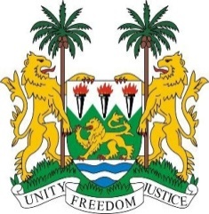
SIERRA LEONE
38th Session of the UPR (3-14 May 2021)

UPR Review of Solomon Islands
10 May 2021 (09:00 – 12:30)

Madam President,

Sierra Leone extends warm welcome to the delegation of Solomon Islands and thanks it for its engagement with the UPR process.

My delegation commends the Government on the strides it has taken in the promotion of human rights since their last review cycle in 2016. This includes our recommendation to reform the Penal Code with a provision criminalizing all forms of sexual violence. Additionally, Solomon Islands enacted the Child and Welfare Act of 2017 and drafted policies promoting gender equality.

These improvements are noteworthy in light of the many environmental challenges as a Small Island Developing State, notably those related to climate change. My delegation encourages the Solomon Islands to continue to work with regional and international partners to seek viable solutions to these challenges.

Sierra Leone makes the following recommendations to Solomon Islands:

- Ratify the core human rights instruments including the ICPPED, CAT and ICRMW.

- Seek required technical assistance to meet its various human rights obligations.

- Consider to submit its overdue reports to the relevant treaty bodies.

- Consider ratifying the Rome Statute

Sierra Leone wishes Solomon Islands success at this third UPR cycle.

I thank you, Madam President

