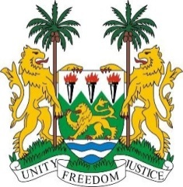
SIERRA LEONE
38th Session of the UPR (3-14 May 2021)

UPR Review of Seychelles
10 May 2021 (14:30 – 18:00)

Madam Vice President,

Sierra Leone warmly welcome and thanks the high-level delegation of Seychelles for the presentation of its national report and for its engagement with the UPR process.

Sierra Leone congratulates Seychelles for its many democratic achievements, including a peaceful transfer of power, the creation of a National Human Rights Commission, and the enactment of several new pieces of legislations designed to improve the rights of women and children.

However, we are concerned about reports of growing gender-based violence. In a constructive engagement, Sierra Leone makes the following recommendations to Seychelles:

- Consider to pass stronger legislation with a view to combating gender-based violence and child abuse.

- Take steps to improve institutional structures and mechanisms to protect children from sexual abuse and economic exploitation.

- Take steps to submit its overdue reports to the relevant treaty bodies

Sierra Leone wishes Seychelles success at this third UPR cycle.

I thank you, Madam Vice President

