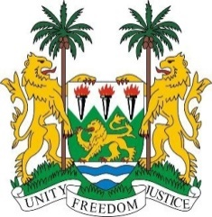
PERMANENT MISSION OF SIERRA LEONE TO
THE UNITED NATIONS IN GENEVA

38th Session of the Universal Periodic Review
(3 – 14 May 2021)

Namibia

Monday 3 May 2021 - 9:00 - 12:30

Madam President,

Sierra Leone warmly welcomes the delegation of Namibia to the third cycle of the UPR and thanks Namibia for its comprehensive national report.
We commend Namibia for repealing outdated and discriminatory laws, enacting the Domestic Violence Act, the Child Care and Protection Act, and enhancing access to justice through the provision of legal aid at the district level. My delegation particularly welcomes the enactment of the Judiciary Act to strengthen the independence of the Judiciary.

In a constructive spirit, Sierra Leone recommends the following for the consideration of the Government of Namibia:

- Review laws and conventions relating to the rights of children to harmonize them with international human rights standards

- Adopt specific legislation protecting the rights of refugees and migrant workers and make provisions for addressing all relevant issues thereunder

- Consider ratifying the International Convention on the Protection of the Rights of All Migrant Workers and their family members.

In conclusion, Sierra Leone wishes Namibia every success in its 3rd cycle review.

Thank you, Madam President.

