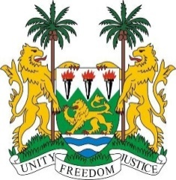
SIERRA LEONE
38th Session of the UPR (3-14 May 2021)

UPR Review of Mozambique
04 May 2021 (09:00 – 12:30)

Madam President,

Sierra Leone thanks the delegation of Mozambique for its national report and for engagement with the UPR process.

My delegation commends the progress made by Mozambique since its second review despite difficult challenges. We welcome progress made in the revision of the Penal Code, the adoption of a National Plan to Prevent and Combat Gender-Based Violence, and the implementation of the Gender Policy and Strategy.

Sierra Leone makes the following recommendations:
- implement concrete measures to reform the education system;

- Investigate and prosecute incidents of violence against persons with albinism; and

- harmonize legislation with a view to preventing child and forced marriage.

Sierra Leone wishes Mozambique success with the implementation of the recommendations it receives during this third UPR cycle.

I thank you, Madam President

