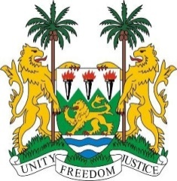
SIERRA LEONE
38th Session of the UPR (3-14 May 2021)

UPR Review of Belgium
05 May 2021 (09:00 – 12:30)

Madam President,

Sierra Leone thanks the distinguished delegation of Belgium for the presentation of its national report and for its engagement with the UPR process.

Sierra Leone welcomes Belgium’s model of working across communities. We note the concerns over ethnic profiling.

In the spirit of constructive dialogue, Sierra Leone makes the following recommendations to Belgium:

- Implement the recommendations of the Working Group of Experts on People of African Descent, including adopting a comprehensive national action plan, that includes data disaggregated by race and clarifies the jurisdiction of anti-discrimination authorities.

- Adopt clear measures to effectively comabt discrimination based on racial, ethnic, national, or religious stereotypes.

Sierra Leone wishes Belgium a successful review.

I thank you, Madam President

