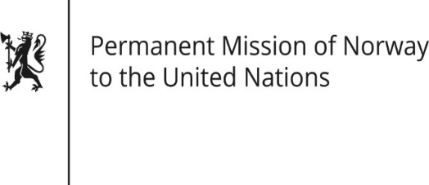

STATEMENT
38th UPR session of the Human Rights Council
on the human rights situation in Niger
as delivered by Mr Sean LOBO

First Secretary Human Rights

5 May 2021

Check against delivery
Madame President,

Norway commends Niger’s historic democratic transition following the recent presidential elections.

Norway recommends that Niger:

1. lifts its reservations to the Convention on the Elimination of all Forms of Discrimination against Women and ratifies the Maputo Protocol, to promote gender equality and women’s rights;

2. takes further action to ensure gender equality and women’s rights, including access to sexual and reproductive health and rights, as well as girls’ right to education, with a view to prevent child marriages and premature pregnancies and promoting girls’ and women’s freedom of choice and autonomy;

3. intensifies its efforts to protect civilians living in areas threatened by violent conflict, including prevention, investigation and prosecution of human rights violations committed by the security forces.

Thank you.

