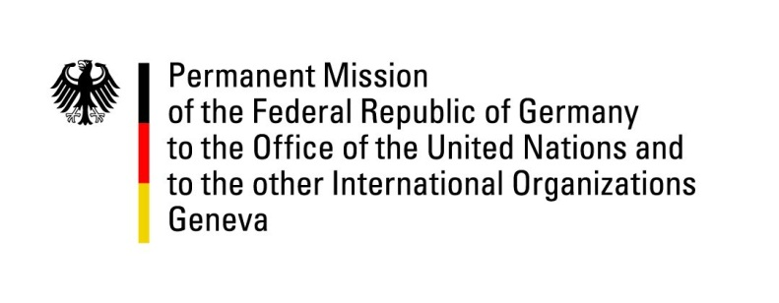

United Nations Human Rights Council

38th Session of the UPR Working Group

Geneva, 6th of May 2021

German Recommendations and advance questions to
SOMALIA

Madam President,
Germany welcomes the delegation of Somalia and commends Somalia for signing and ratifying the Kampala Convention of the African Union for the Protection of Internally Displaced Persons and ratifying the UN Convention on the Rights of Persons with Disabilities.
Germany remains concerned about the situation of women and girls, especially with regard to the widespread sexual and gender based violence. Furthermore, the number of attacks against and arrests of media representatives as well as numerous killings of journalists remains alarming. Germany is also concerned that current political crisis may lead to conflict and an increase of Human Rights violations.

Germany therefore recommends to:

- Effectively protect freedom of expression and press freedom by adequately operationalizing the prosecutor for crimes against journalists and revising the media law and the penal code in compliance with international standards.
- To withdraw the Sexual Intercourse Related Crimes Bill and pass the originally introduced Sexual Offences Bill.
- Effectively protect women and girls from sexual exploitation and violence as well as ensure that perpetrators are prosecuted and tried in fair proceedings based on the rule of law.
- Adopt a moratorium on executions with the goal to abolish the death penalty.

Thank you, Madam President.
GERMAN ADVANCE QUESTIONS TO SOMALIA:
- What measures will Somalia take to provide necessary assistance and protection to IDPs, including the halt of forced evictions?
- Germany is concerned about the ongoing violence against journalists and media workers and would like to inquire what concrete steps Somalia will take to bring the media law and penal code in line with international standards and to provide the prosecutor for crimes against journalists with the necessary powers to independently investigate attacks and prosecute against journalists?
- Germany welcomes the steps taken toward the establishment of the Human Rights Commission and would like to inquire when and how Somalia will finalize the establishment and operationalization of the Commission and what powers it will be given to operate independently and effectively?
- How will Somalia seek to reduce and punish sexual and gender based violence against women and girls, protect victims of sexual and gender based violence, and ensure that perpetrators are held accountable?

