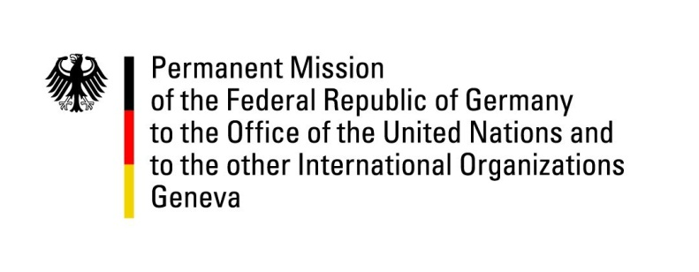

United Nations Human Rights Council

38th Session of the UPR Working Group

Geneva, 10th of May 2021

German Recommendations and advance questions to
Solomon Islands

Madam President,
Germany welcomes the Solomon Islands to the UPR. Germany commends the Solomon Islands for establishing the Anti-Human Trafficking Advisory Committee.
Germany remains concerned about the protection of children, in particular of children with disabilities.

Fully aware of the very difficult situation Solomon Islands finds itself in due to the covid-19 crisis, Germany recommends to:
- Ratify ICCPR and CAT.
- Protect children’s rights by ratifying the Optional Protocols to the CRC and bringing national legislation in line with the CRC, in particular the Marriage Act, Labour Act, Education Act and the Penal Code and improve access to schools and regulate school fees.
- Ratify CRPD and develop a national policy for the benefit of persons with disabilities.
- Ensure the definition of non-discrimination in the Constitution is comprehensive and in line with international human rights standards and includes sexual orientation and gender identity as prohibited grounds for discrimination.
- Ensure gender equality, including with regard to the right to nationality by amending the Citizenship Act.
- Ensure the provision of and access to age-appropriate information, education and adolescent-friendly comprehensive sexual and reproductive health services for adolescents and youth, including those with disabilities.
Thank you.
GERMAN ADVANCE QUESTIONS TO SOLOMON ISLANDS:
- What steps are being taken to ensure media freedom on Solomon Islands as well as to protect the right to freedom of expression?

- Since the ratification of the Convention on the Elimination of All Forms of Discrimination against Women in 2002, what has been done to protect women's rights on Solomon Islands? What concrete steps are being taken to ensure the formal justice system is accessible to all, especially in rural areas and for those in marginalized and vulnerable situations, including women, lesbian, gay, bisexual, transgender and intersex persons, persons with disabilities and elderly persons?

- What concrete steps are planned to establish a national human rights institution in compliance with the Paris Principles?

