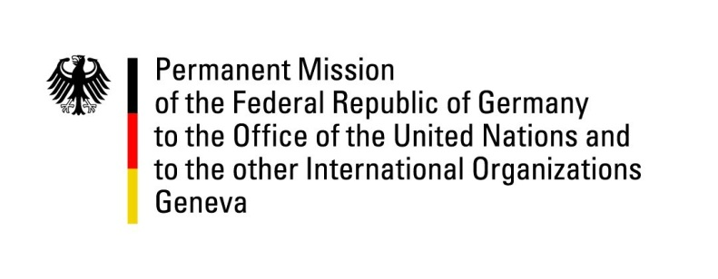

United Nations Human Rights Council

38th Session of the UPR Working Group

Geneva, 12th of May 2021

German Recommendations and advance questions to
Singapore

Madam President,

Germany commends Singapore for repealing the immunity for marital rape.

Germany recommends to:
- Eliminate the mandatory character of the death penalty and establish an official moratorium.
- Ratify the ICCPR, the ICESCR and CAT and implement them into national law.
- Amend or repeal the Sedition Act, the Administration of Justice Act and the Protection from Online Falsehoods and Manipulation Act to ensure they comply with international human rights standards.
- Establish a National Human Rights Institution in line with the Paris Principles.

Thank you.
GERMAN ADVANCE QUESTIONS TO SINGAPORE:
- What is the status of the consultation process on gender equality? What concrete measures does Singapore envision to tackle gender-based violence and ensure victims are treated in a gender-sensitive manner?

- How does Singapore intend to ensure the right to privacy and data protection in view of the advancing digitalization of society?

- What steps does Singapore take to improve the situation of foreign workers, inter alia by easing the conditions applicable in case of change of employer?

- How does Singapore plan to better protect LGBTI minors and vulnerable adults from psychological violence, including conversion practices?

