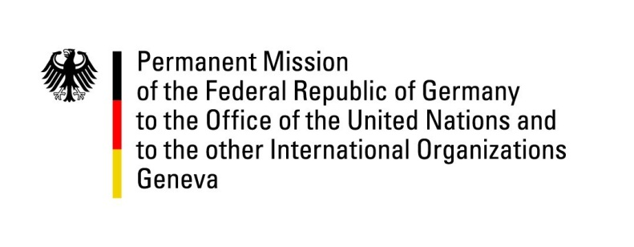

United Nations Human Rights Council

38th Session of the UPR Working Group

Geneva, 10 May 2021

German Recommendations and advance questions to
Seychelles

Madam President,
Germany welcomes the delegation of Seychelles to this UPR.

We commend Seychelles for ratifying the International Convention for the Protection of All Persons from Enforced Disappearances, for decriminalizing consensual sexual relations between adults of the same gender and for reforming the National Human Rights Commission.

We also welcome the improved prison conditions, the coming into force of the Access to Information Act 2018 and the Anti-Corruption Act 2016 as well as the start of operations of the Truth, Reconciliation, and National Unity Commission.

In view of the growing globalization and the increased mobility of citizens from Seychelles, Germany would like to recommend, nevertheless, to explore possibilities to extend the right to vote in presidential and parliamentary elections to Seychelles citizens living abroad.

Thank you, Madam President.

