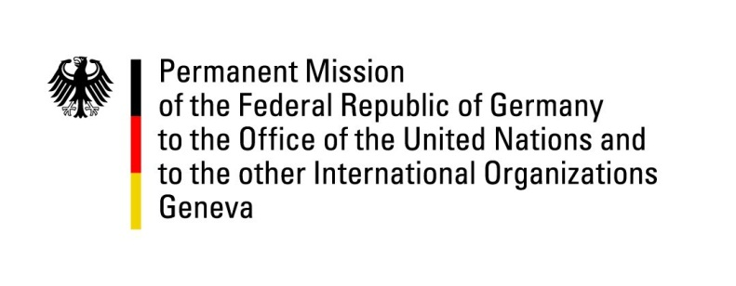

United Nations Human Rights Council

38th Session of the UPR Working Group

Geneva, 5 May 2021

German Recommendations and advance questions to
Paraguay

Madam President,
Germany welcomes the delegation of Paraguay to this UPR.

We commend Paraguay for its successful efforts to implement previous UPR recommendations, such as the ratification of the Kampala Amendments to the Rome Statute as well as the laws from 2016 and 2018 respectively, improving women’s and children rights.

However, Germany remains concerned about continuing corruption, intimidation and threats against journalists and human rights defenders, as well as domestic violence, despite the just mentioned legal improvements.

Germany therefore recommends to:
- Strengthen the judicial system, especially in the field of criminal jurisdiction, including with a view to overcome backlogs of cases.
- Beyond constitutional efforts to address discrimination, adopt a law against all forms of discrimination, including discrimination based on sexual orientation and gender identity.
- Adopt all necessary measures to prevent and stop the criminalization of human rights defenders and journalists.
- Intensify efforts to combat corruption in order to achieve a more equal and sustainable social and economic development.

Thank you, Madam President.
GERMAN ADVANCE QUESTIONS TO PARAGUAY:
- Germany has in the past two cycles of the UPR recommended to “Develop a comprehensive and forgery-proof land registry to enable indigenous communities to hold legal titles to their ancestral land” – these recommendations have been supported by Paraguay. However, according to para 201 of the national report, the bill is still in preparation. Conflicting land titles continue to be a problem for the land owners and for domestic and foreign investors. Can you elaborate on the delay in setting up the land registry that would benefit indigenous communities? What steps have been taken towards setting up a land registry?
- Domestic violence including femicides continues to be problematic. While recognising the 2018 law to protect women and children, what further measures is the Government of Paraguay planning to enhance the security of women and girls, i.a. against domestic violence?
- The protection of human rights defenders and journalists is of paramount importance to ensure promotion and protection of human rights. However, there are reports of threats and harassments. In the past, there have been extrajudicial killings in the context of reporting on drug trafficking or organized crime or when protesting against illegal land confiscations. What is the Government doing in order to better ensure the security of human rights defenders and journalists?
- Which measures is the Government of Paraguay planning in order to address the prison situation, including overcrowding, with the aim to bring the conditions in the prisons into conformity with international standards?
- Criminal cases brought before Paraguayan courts often take several years until a verdict is reached. The system of penal jurisdiction seems to be chronically overloaded. What measures does the Government of Paraguay take in order to overcome this backlog and to enhance the efficiency of the Paraguayan penal jurisdiction?
- Teenage pregnancies remain frequent. Which steps has the government taken related to protect the young women’s sexual and reproductive health?

