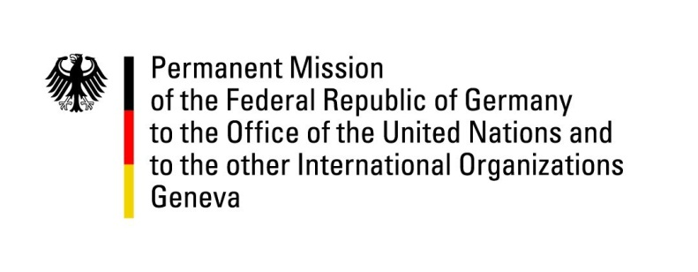

United Nations Human Rights Council

38th Session of the UPR Working Group

Geneva, 7th of May 2021

German Recommendations to
Palau

Madam President,
Germany welcomes the delegation of Palau and commends Palau for acceding to the Palermo Protocol (Protocol to Prevent, Suppress and Punish Trafficking in Persons, especially Women and Children, supplementing the UN Convention against Transnational Organized Crime) and for adopting a national action plan against trafficking in persons. Germany remains concerned about sexual and gender based violence, including domestic violence. We acknowledge the multiple challenges posed by climate change.

Germany recommends to:
- Proceed with the ratification of CEDAW, CCPR, CESCR, CED and other core Human Rights treaties and seek in this regard, where needed, the support of the OHCHR regional office for the Pacific.
- Implement a systematic approach against trafficking in persons, especially women and children.
- Take measures to enable systematic prosecution of cases of domestic and sexual and gender based violence.
- Ratify or accede to the Rome Statute.
- Step up efforts to establish a national human rights institution in accordance with the Paris Principles.

Thank you.

GERMAN ADVANCE QUESTIONS TO PALAU:
- Palau has signed a number of important human rights treaties; however, ratification is still pending. What efforts does the Government of Palau undertake to ratify the already signed Human Rights treaties? What support would be helpful in this process?
- In the second UPR cycle, Palau accepted the recommendation to establish a national human rights institution. What concrete steps has the Government of Palau undertaken and which further steps does it intend to take in order to bring forward the establishment of a National Human Rights Institution in accordance with the Paris Principles?

