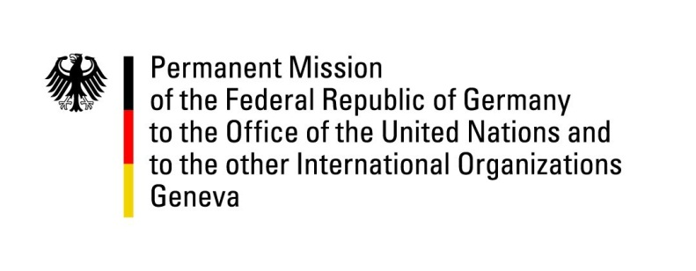

United Nations Human Rights Council

38th Session of the UPR Working Group

Geneva, 3rd of May 2021

German Recommendations and advance questions to
Namibia

Madam President,
Germany welcomes the delegation of Namibia and commends Namibia for the government’s efforts in combatting violence against women and in protecting the rights of children.

Germany remains concerned that incidence rates of gender-based and domestic violence still remain high. Also the prevalence of child marriage among girls has been at 18, 4% in 2020.

Germany therefore recommends to:
- continue efforts to combat violence against women and children with a particular emphasis on providing support measures to victims, such as access to Magistrate's courts and police stations.
- detain children only in specialized child detention facilities.
- increase efforts to curb practices of marrying children and teenage pregnancies.
- revise laws discriminating persons based on their sexual orientation and gender identity, especially LGBTIQ+-persons, in particular the law which criminalizes sodomy between consenting adult men.

Thank you, Madam President.

