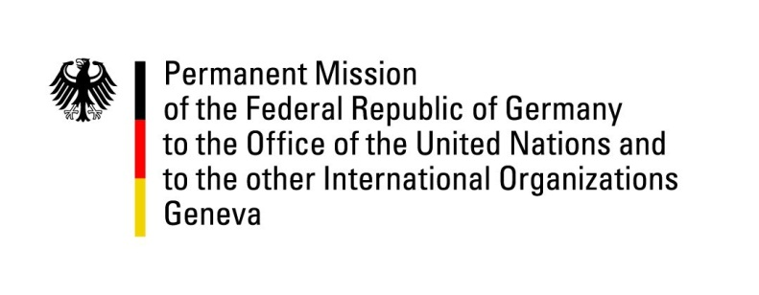

United Nations Human Rights Council

38th Session of the UPR Working Group

Geneva, 4th of May 2021

German Recommendations and advance questions to
MOZAMBIQUE

Madam President,
Germany welcomes the delegation of Mozambique and commends Mozambique for having adopted key legislation that strengthens the rights of girls and women and a National Plan on Women, Peace and Security for 2018-2022.

Germany remains concerned about the human rights situation in Cabo Delgado as well as about restrictions targeting independent media and journalists.

Germany therefore recommends to:
- Step up efforts to ensure that the principles of International Humanitarian and Human Rights Law are adhered to in Cabo Delgado, for example protection of civilians and ill-treatment prevention.
- review the proposed media and communication laws with the aim of guaranteeing freedom of opinion and expression through free and independent media.
- continue the constructive policy dialogue on human rights and governance with the EU.

Thank you, Madam President.

