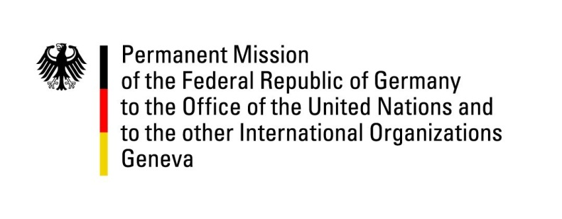

United Nations Human Rights Council

38th Session of the UPR Working Group

Geneva, 4th of May 2021

German Recommendations and advance questions to
Estonia

Madam President,
Germany welcomes the delegation of Estonia to the UPR. We commend Estonia for its efforts to better integrate minorities and other vulnerable groups as well as for the establishment of a National Human Rights Institution in compliance with the Paris Principles.

At the same time, Germany encourages Estonia to ensure that the Registered Partnership Act will be fully implemented in law and practice.

Germany recommends to:

- take effective administrative and legislative measures to combat hate speech online and offline.

- amend the Equal Treatment Act to include the explicit prohibition of discrimination based on religion and belief, age, disability or sexual orientation.

- accede to the Optional Protocol to the Convention on the Elimination of All Forms of Discrimination Against Women as well as to the Optional Protocol to the Convention on the Rights of the Child.

Thank you, Madam President.

GERMAN ADVANCE QUESTIONS TO ESTONIA:
- Which progress has Estonia made in establishing an institution (ombudsman, commissioner, etc.) to protect the rights of minorities and immigrants?

- Germany commends Estonia for its digitalization efforts, which, as outlined in the national report, have made it possible to transfer certain activities and tasks to the electronic environment during the pandemic. How does Estonia ensure the right to privacy vis-à-vis these digitalization efforts?

