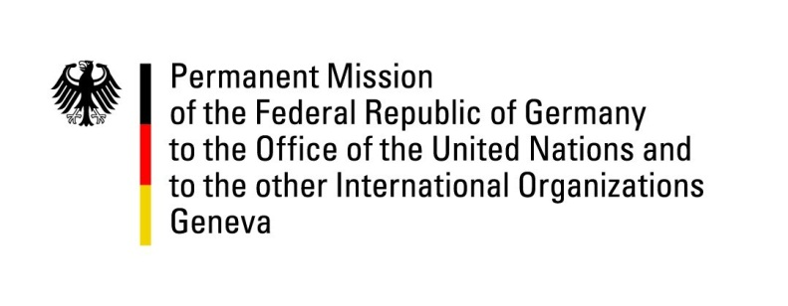

United Nations Human Rights Council

38th Session of the UPR Working Group

Geneva, 6th of May 2021

German Recommendations and advance questions to
Denmark

Madam President,
Germany welcomes the delegation of Denmark to this UPR.

We commend Denmark for its steadfast commitment to the promotion and protection of human rights, in particular regarding the fight against torture.

Denmark’s progressive legislation on social rights, gender equality and the rights of the LGBTI community stands out remarkably in a world plagued by a push-back on human rights achievements.

At the same time, Germany would like to express concern about reports on the living conditions in the Ellebaek Centre for Foreigners.

Germany recommends to:
- ratify the International Convention for the Protection of All Persons from Enforced Disappearance in order to strengthen the international legal regime against enforced disappearances.
- review conditions and treatment of foreign nationals without residence entitlements at the Ellebaek Centre for Foreigners.

Thank you, Madam President.
GERMAN ADVANCE QUESTIONS TO DENMARK:
- Recalling reports on conditions in the Ellebaek Centre for Foreigners, how will Denmark improve the treatment of migrants and asylum seekers in detention centers?
- Is Denmark considering to change the current CPR-registry regulations in order to ensure that all parents, including those living in same-sex-relationships, can be adequately registered?

