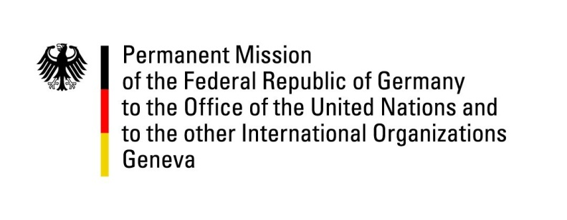

United Nations Human Rights Council

38th Session of the UPR Working Group

Geneva, 5th of May 2021

German Recommendations and advance questions to
Belgium

Madam President,
Germany welcomes the delegation of Belgium to the UPR. Germany appreciates Belgium’s steadfast commitment to the promotion and protection of human rights worldwide, especially but not only during its recent term in the United Nations Security Council.

Germany underscores the importance of effective processes and competencies for the Federal Institute for the Protection and Promotion of Human Rights. Germany also notes the importance of the zero-tolerance policy agreed upon by the Belgian government in light of individual instances of inappropriate use of force or racist behavior in the Belgian police force

Germany recommends to
Ensure, that the Federal Institute for the Protection and Promotion of Human Rights is allocated all competencies in line with the Paris Principles,

Thank you, Madam President.
GERMAN ADVANCE QUESTIONS TO BELGIUM:
- When will Belgium ratify the Optional Protocol to the UN Convention against Torture (OPCAT) and create a national anti-torture prevention mechanism?
- What is the state of play concerning Belgium’s efforts to increase capacities of the penitentiary system, also with regard to providing additional psychological support for mentally ill or addict detainees?

