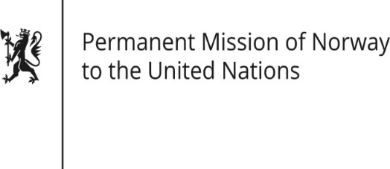

STATEMENT
38th UPR session of the Human Rights Council
on the human rights situation in Singapore
as delivered by

Ms Anniken ENERSEN,
Minister-Counsellor Human Rights

12 May 2021

Check against delivery
Madame President,

Norway welcomes Singapore’s participation in the UPR, and notes the positive steps that Singapore has taken since the last review, including the ratification of the International Convention on the Elimination of All Forms of Racial Discrimination.

Norway recommends that Singapore
1. establishes a moratorium on the use of the death penalty, with a view to abolition;

2. abolishes the practice of corporal punishment as a judicially imposed punishment;

3. removes all existing obstacles to the registration of LGBTI organisations;

4. reviews the Protection from Online Falsehoods and Manipulation Act as well as other laws such as the Defamation Act, to ensure that the right to free speech [online as well as offline] is sufficiently protected.

Thank you.

